Mobile Dev weekly log

## Week 1

Set up basic scene and source control, working on concept idea for the game.

## Week 2

Came up with the idea for the game, a mobile game where you use in build haptics to control towers to defend your home. Developed a basic gyro system that can be adapted to fit the final game. Drew the initial sketch in paint to set up what the game should be.

turret

boulder

trap

enemies

## Week 3

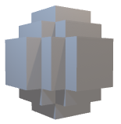Improved concept established futuristic theme. Set up base game where enemies run at a checkpoint until they kick you back to the main menu. Created models for enemies and boulder using Goxel and MagicaVoxel.

## Week 4

Develop microphone system used to knock back the opponent. Adapted gyro to let you control a boulder that moves back and forth to kill enemies. Created adaptive UI and added music and particle systems currently the Adaptive UI is having small issues on certain devices where rotating the menu is causing the UI to squash in awkward places and in the case of some menus not cover the whole screen.

## Week 5

Implemented preserved user preferences, created Icons that let you drag and drop objects into the game. Currently working through issues of accuracy, as the game perspective can sometimes mean that the drag and drop won’t drop the object exactly where you dragged it to on the screen.



## Week 6

Created more models for the game, and started working on implementing advertisements within the game, currently running into issues where banner ads are not appearing when they should be and when they do appear they cannot be hidden and get permanently stuck.

## Week 7

Finalised banner and interstitial ads within the game. These are currently only in their testing stage so wont display real ads however, I plan to set up real ads within the gameA purple and white background with white text

## Week 8

Mostly focussed on other projects, however added a spike trap drag and drop to the game.

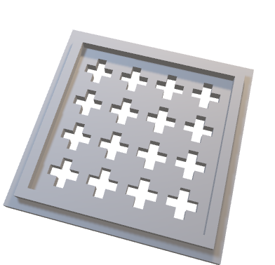

## Week 9

Mainly focussing on other projects however, I added lives to the game and set up the game loop. The idea being endless waves of enemies spawn at you and you have to set up traps to fend them off.

## Week 10

Set up my unity account in connection with Google play in order to develop In app purchases and google specific services. Planning to develop google play games services in order to add leaderboards and achievements to the game.

## Week 11

Fixed an issue preventing the game from being built, the in-built unity gradle files had conflicts with the ads in the project so I had to import a custom gradlew.bat file in order to continue developing the game, as well as use the mobile dependency resolver to resolve multiple issues such as the game creating duplicate classes within the game. Additionally, I started developing in- app purchases.

## Week 12

Completed In-app purchases with two types: consumable gain health purchases that give you 30 health and a permanent ad removal purchase. In addition I added CandyCoded vibrations to the game which are used to a small degree in the menus and UI of the game and then are implemented fully into the Microphone system which will scale the intensity of the vibrations to how loud you shout into your microphone. Currently having issues with lower vibrations not being noticeable within the game.

## Week 13

Worked on setting up Google Play console. Created a google developer account and started working through the initial setup phase of the project.

## Week 14- 18

Had to switch focus during the holidays to working on AI project.

## Week 19

Set up final build, created build functional on the google play store, added voice lines more particle systems and created final video. Attempted to create FMOD sound effects and google play services however was unable to get them to function with the google play store build of the game. Resolved bugs in which the google play version of the game would remove certain collisions and prevent parts of the game from being functional.